LOCAL EVENT FINDER
@CREATIVITY THINK (9483175986/7019689991)

ABSTRACT:
Local Event Finder is a web application designed to help users discover and participate in nearby events. Users can browse event listings, filter by location, RSVP, receive reminders, and access dashboards with personalized analytics. Administrators manage event creation, locations, and generate analytics reports to monitor engagement. The backend uses Django and Django Rest Framework for secure data management, API handling, and business logic, while the frontend leverages React, Leaflet, and Axios for interactive maps, location-based filtering, and responsive dashboards. This system enhances event discovery and administrative oversight in a centralized platform..

INTRODUCTION OF THE PROJECT:
Urban dwellers, travelers, and marketers often struggle to discover local events efficiently. Local Event Finder solves this problem by offering a web platform where users can search for events, RSVP, join activities, receive notifications, and track participation through dashboards. Administrators can manage events, update locations, and analyze engagement through analytical reports. Django and Django Rest Framework provide a secure backend, while React with Leaflet ensures interactive maps and real-time location-based filtering, delivering an intuitive user experience for both participants and administrators..

PROJECT OBJECTIVES:

• Enable users to discover nearby events based on location
• Allow RSVP and participation tracking
• Provide notifications and reminders for upcoming events
• Display user dashboards with analytics on attended events
• Allow administrators to add and manage events and locations
• Generate reports and analytics dashboards for monitoring engagement
• Enhance local community participation and event visibility

PROBLEM OF THE STATEMENT:
Finding local events can be challenging without a centralized platform, leading to missed opportunities for participation and inefficient promotion for organizers. Users may not know about nearby events or relevant activities, while administrators lack real-time insights into attendance and engagement. Local Event Finder addresses these challenges by providing an interactive map-based event search, RSVP management, and dashboards for both users and administrators to monitor activity, engagement, and performance..

MOTIVATION OF THE PROJECT:
• Increase accessibility to local events for users
• Provide real-time location-based event discovery
• Facilitate RSVP management and notifications
• Enable administrators to track participation and engagement
• Promote community involvement and event visibility

BLOCK DAIGRAM OF PROJECT:

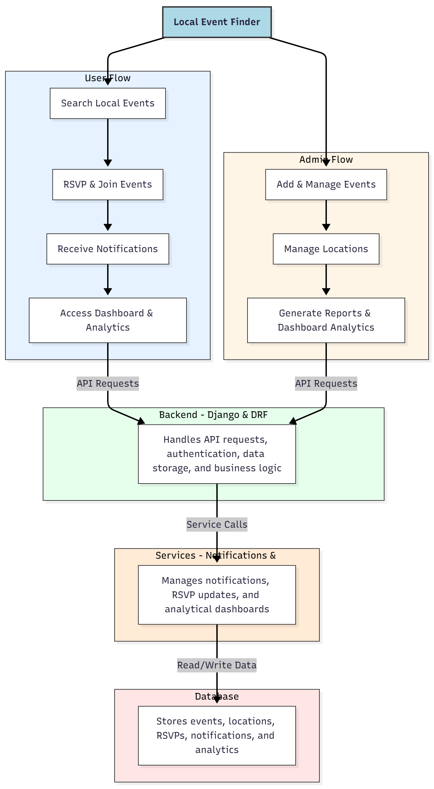

WORKING OF THE PROJECT:
Users search for local events using filters and interactive maps, RSVP to events, receive notifications and reminders, and track their activity through dashboards. The backend processes API requests, handles authentication, and stores all data securely. Services manage notifications, RSVP updates, and analytics dashboards. Administrators add and manage events, oversee locations, and generate reports and analytics dashboards to monitor engagement. This system ensures efficient local event discovery and centralized administrative control..

SOFTWARE REQUIREMENT:
- Backend:
  - Python 3.x
  - Django
  - Django REST Framework
  - SQLite/PostgreSQL
- Frontend:
  - Node.js and npm
  - React.js
  - Axios
- Development Tools:
  - Visual Studio Code
  - Postman (for testing APIs)
  - Git/GitHub (for version control)
- Server/Deployment (Optional):
  - Gunicorn, Nginx, or Heroku/AWS for hosting

ADVANTAGES OF THE PROJECT:

• Centralized discovery of local events
• RSVP and participation tracking
• Real-time notifications and reminders
• Interactive maps for event location filtering
• Administrative management of events and locations
• Analytical dashboards for engagement tracking
• Web-based and multi-device accessible
• Promotes community involvement

APPLICATIONS OF THE PROJECT:
• Urban residents discovering city events
• Travelers seeking local activities
• Marketers promoting events and campaigns
• Event organizers tracking RSVPs and attendance
• Community groups managing local activities
• Schools and colleges promoting student engagement
• Municipal bodies monitoring public events
• Dashboards for data-driven insights into local events

REFERENCES:

- Django REST Framework Documentation — Django Software Foundation. Django Documentation. Available: https://docs.djangoproject.com/
- Django REST Framework. DRF Documentation. Available: https://www.django-rest-framework.org/
- React. React Official Documentation. Available: https://reactjs.org/docs/getting-started.html
- Redux. Redux Documentation. Available: https://redux.js.org/introduction/getting-started
- PostgreSQL Global Development Group. PostgreSQL Documentation. Available: https://www.postgresql.org/docs/
- MySQL. MySQL Reference Manual. Available: https://dev.mysql.com/doc/
- Git. Git Documentation. Available: https://git-scm.com/doc
- Node.js. Node.js Documentation. Available: https://nodejs.org/en/docs/
- Axios. Axios Documentation. Available: https://axios-http.com/docs/intro
- Socket.io Documentation – https://socket.io/docs/

